Demystifying the Press Release Format + Free Template

WRITTEN BY: Kelly Main
Published August 6, 2021
Kelly is a former Google Tech Entrepreneur and Apple Developer who has counseled businesses of all sizes and growth stages. You can find her expertise across Fit Small Business in marketing, business website, and business trend content.
This article is part of a larger series on Press Releases.
Learn More About Press Release
- The Ultimate Guide to Writing a Press Release
• What Is a Press Release
• Types of Press Releases
• How to Write a Press Release
- Demystifying the Press Release Format
• Press Release Best Practices
• How to Write an AP Style Press Release
• What Makes a Good Press Release
• Press Release Writing Mistakes
• Best Press Release Examples
• How to Write a Boilerplate
• Press Release Writing Services

- How to Send Press Releases
- Press Release Analytics
Your press release needs more than just a great story to grab media attention. It must also follow the standard press release format, which contains your logo, release date, contact information, headline, a three-to-four paragraph body, a boilerplate, a link to your website, and relevant multimedia. By upholding this journalist-expected format, your press release has a better chance of landing media coverage.
If you’re not an expert, writing a press release that effectively gets the media’s attention is no easy feat. For this reason, many businesses leave press release writing and distribution up to professionals, like the experts at eReleases. Give your press release a leg up and get started with eReleases today.
Visit eReleases

Free Press Release Template
To ensure you get your formatting right, download our free press release template before writing your release to guide you through each of the sections described below.

Press Release Format by Type
While all releases follow the same general press release format, they vary slightly depending on the purpose of the press release, the type of media you include (e.g., images, video), and your overarching goal. For example, the information and media detailed within a book press release will differ from those in an event press release.
Here are four common types of press releases with guidance on what content to include and their specific formatting:
- New hire press release
- Book press release
- Grand opening press release
- Event press release
If none of these fit the bill, use the standard press release format and follow the instructions below to write your newsworthy story using our free press release template.

The Required Elements of the Press Release Format
A press release contains your business logo, a headline, a lead paragraph summarizing the announcement, and a newsworthy angle. Your press release will have three to four paragraphs of text within the body, hyperlinks, social media links, quotes, and multimedia. It concludes with information about your organization (your boilerplate) and contact information. The total length should be between 300 and 500 words.

Logo
To boost the brand awareness impact of your press release, your company logo should be prominently displayed at the top of your press release. When sending your press release via email, be sure to also upload a 200×200-pixel version of your logo so journalists can include it in their stories. That way, journalists don’t have to try to extract a copy of your logo from the press release, which would likely reduce image quality.

Contact Information
Put your contact information to the right of the logo. This includes the ways a journalist can contact the person within your company who can answer questions about this press release. Include their name, email address, and phone number so journalists can easily reach the primary contact using the method they prefer. This text should be left-justified, but positioned along the right margin. Here is how the contact information on your release should appear:
Contact: John Smith
Phone: (123) 456-7890
Email: john.smith@email.com

Release Date or Dateline
The release date indicates when you want the release to be published and the information in your press release to be written about. It tells journalists whether you want your press release news written about or published immediately or at a future time.
Add your desired publication date and time in the top-left corner of your press release in all caps and in bold. If your press release is ready to be distributed right away, include the words “FOR IMMEDIATE RELEASE” at the top left corner of your press release.
Alternately, when you want the media to hold onto your press release for future release (but you are sending it ahead of time to ensure coverage), it’s called an “embargoed” release. In that case, put the words “EMBARGOED FOR RELEASE” in the top left-hand corner and then add the date and time you want the press release and any related media stories to go live.

Headline
A press release headline appears at the top and center of your press release but below the logo, contact information, and release date. Keep your headline short and to the point, typed in 14-point size, bold, and centered. Try to stay within the 65- to 80-character range, and use language that is clear and easy to understand.
The headline is usually the most eye-catching part of your press release, and you need it to compel people to read your press release. It should reflect the most newsworthy angle of your release―the main reason your target audience would care about your news. When you distribute your release to journalists who share that audience, they are more likely to publish your story, because it is clear why their audiences would care.
For more help, learn how to write a press release.

Subheader (Optional)
A subheader can be up to 120 characters in length and appears directly below your headline. Subheaders allow you to capture readers’ attention and help them better understand what your press release is about. It gives you another opportunity to develop your story angle with a teaser that encourages further reading. It should be formatted in italicized 12-point Times New Roman font and in title case (title-style capitalization).

Place Stamp & Date
The place stamp and date of your lead paragraph is separated from the first body paragraph by a dash. It needs to show the location (usually the city) where the press release is coming from and the date it is published. Both location and date (full date including month, day, and year) should be in bold and should look like this: CITY, ST. (Month Day, Year) -.
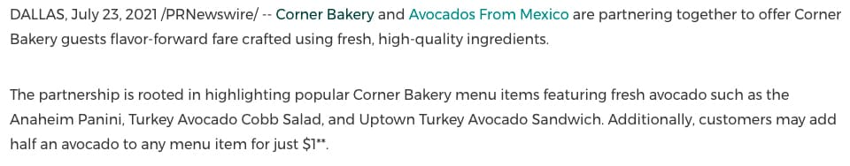
Location and date line for press releases

Introduction Paragraph
The first paragraph, often called “the lead,” should answer the who, what, when, where, why, and how of the press release. Its purpose is to give journalists a quick snapshot to decide whether the story is a good fit for their audiences.
Stick to basic facts here and avoid hyping or trying to sell products or services, but do mention the angle that makes your announcement newsworthy. Text should be single spaced in regular/normal (not bold or italicized) 12-point Arial or Times New Roman font.
Also note how the introduction includes links. It is a common practice to include hyperlinks to your business’s website or supporting material within your introduction paragraph, and it’s a good way to drive more traffic to your website.
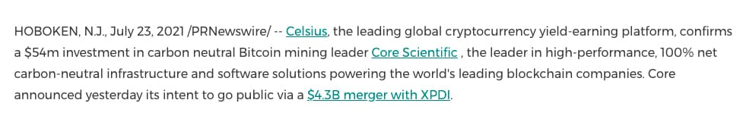
Press release introductory paragraph example

Body Paragraphs
The next few paragraphs in the body of your press release should serve to complete the story you introduced in the headline and first body paragraph. It should zero in on the newsworthy angle of the story and elaborate on it with details journalists can use to develop that angle.
Be sure to follow AP style guidelines so media outlets can use your text as is. Use short paragraphs, of approximately two to four sentences each, and feel free to include statistics in addition to graphics to back up your claims.
Finally, include details that make it super-easy for journalists to cover your story. If, for example, you are inviting a journalist to cover a company event, be sure to include details on how they can attend the event for free.
If your event is open to the public or specific groups, you should also include information about how they can attend the event, such as details about how to RSVP or register. That way, journalists have the details needed to invite their audiences beforehand and to attend themselves to write a follow-up story. This means double the coverage from one press release.
If you would rather be running your business than writing stories for the press, or you aren’t sure how best to convey your newsworthy event, you can outsource this task by hiring a press writing service, like eReleases. Their command of the press release format and ability to hone in on newsworthy angles makes it more likely your news will be picked up by media outlets. Check out our guide on press writing services for more information.

Quotes
As part of any good news story, quotes allow journalists to round out their stories with a human perspective. For example, if you have a happy customer, you can add a testimonial quote. If you are introducing a new C-level employee, quotes from the new hire about how happy they are about their new role, and from another executive about what this change in the C-suite will mean for the business or its customers, offers more depth to the story.
Include a couple of quotes so journalists can choose their human perspective angle. Just be sure your quotes add value and don’t just repeat the same content you wrote in the body of your press release.
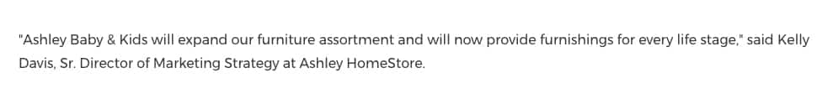
Example of a press release with a quote

Interactive Elements (Optional)
Interactive elements are parts of your press release that journalists must complete an action to consume, such as clicking a link, playing a video, or downloading something. They allow journalists and readers to further explore your story while giving your business more ways of tracking their preferences and actions.
In addition to the interactive elements mentioned above, common interactive content includes hashtags, social media handles, interactive images, and downloadable infographics and portable document files (PDFs), such as an e-book, report, or case study. These content elements aid journalists in digging deeper as they cover your news.
For example, a branded hashtag tied to a product launch gives journalists a way to see firsthand what consumers think of it, which influencers are creating buzz around it, and be alerted when upgrades or complimentary products come out. Likewise, interactive images could walk journalists through a virtual product tour and allow you to track how far they went in the product tour, and which product features they lingered on due to heightened interest.

Boilerplate
The final paragraph of your press release is called a boilerplate. It’s your company’s “About” section that appears at the very bottom of your press release. This is where you write about your company’s background, awards, amount of time in business, or anything else that might be of interest about your company.
You should also provide a link to your website and a media contact, which is the primary email or phone number a journalist should contact for more information. Your boilerplate should be less than 100 words. All companies mentioned in the press release should have their own boilerplate.
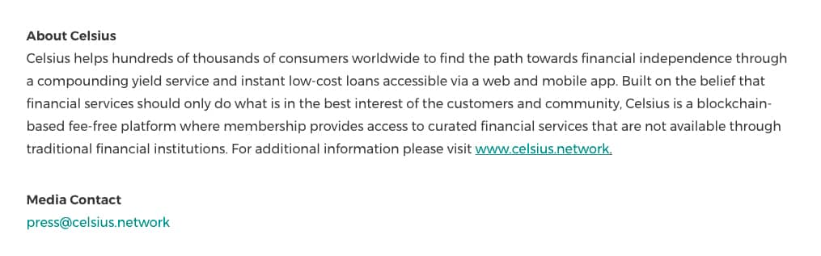
Press release boilerplate example
For more details on how to write a boilerplate, read how to write a boilerplate.

End Notation
Finally, include an end notation at the bottom of your press release document. This tells the media they have accessed the whole document. While you should stick to one page (or about 500 words), if your release extends to two pages, the first page should end with “-more-” centered at the bottom of the page. Whether your press release is only one page long or has a second page, the final page should end with three centered pound signs, like this: ###.

Final Note & Call to Action (CTA)
Once you have ended the text of the press release, it’s a good idea to put one final note at the bottom that encourages someone who wants more information to reach out to you. A simple sentence like this is appropriate (formatted in 12-point Times New Roman or Arial font):
“If you would like more information about this topic, please call [name] at [phone number] or email [email address].”
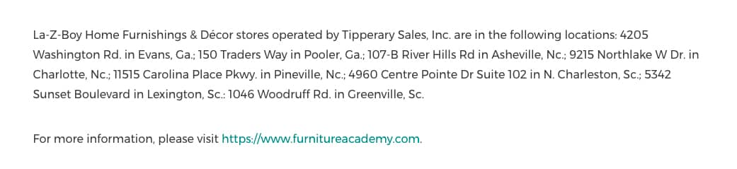
Example of a press release CTA

Multimedia
Offering journalists multimedia resources in your press release allows them to more effectively craft a compelling story. Press releases with multimedia create more engagement across platforms like social media, blogs, and even print outlets. This is because journalists know that videos and other multimedia can increase engagement threefold.
While often included only when you pay $100 to $200 extra when using a press release distribution service, embedded videos and images are more engaging than simply an attached image or linked video. Embedded multimedia is viewable directly from published news wire stories, while attached multimedia must be accessed via hyperlink from within the article.
That said, many press release distribution service plans include free multimedia attachments, which still provide journalists with visuals they can use to add depth to their stories. Each service has guidelines for formatting the multimedia that is attached or will be embedded in your press release, including file size, type, and quality and resolution limitations.
Be sure to include your original files as well as reformatted files so your media contacts can use them if they believe it will add value to their story angle. When emailing your press release to the media, include links to original assets so they are available in their highest-quality form and not just a reduced-size copy (which is often of lower quality).

